A STUDY OF INTERFACES AND SOLAR CELLS FABRICATED BY USING CSS-CdS

Presented as a first-year report

Mohammed K. Al Turkestani

May 2007
CHAPTER 1: INTRODUCTION
1-1 General Introduction to Solar Cells:
Fossil fuel such as oil and natural gas is the main source of energy nowadays in the world. However, it is not only infinite but it is environmentally destructive. For example, burning fossil fuel produces CO₂ which traps heat and, as a result, increase the temperature of earth. Therefore, finding other sources of energy is an important issue. Among the alternatives that can be used is Solar Energy.

Solar energy is a clean and a renewable source of electricity. It is all about converting sun light to electricity power. Using only 1% of the earth’s land area with only 10% efficient solar cells can provide double the amount of energy needed nowadays [1]. However, it needs more investigation to produce more economical and efficient cells.

Device used to generate this kind of power, which are solar cells, are p-n junctions. It consists of two kinds of semiconductors, p-type and n-type. When these materials are contacted together electrons form n-type side flows to p-type side and holes flow in the other direction leaving positive and negative ions in n-type and p-type sides respectively. The ionized atoms create electric field resisting the flow of charges. The layer containing these ionized atoms is called the Depletion Layer as shown in figure 1.

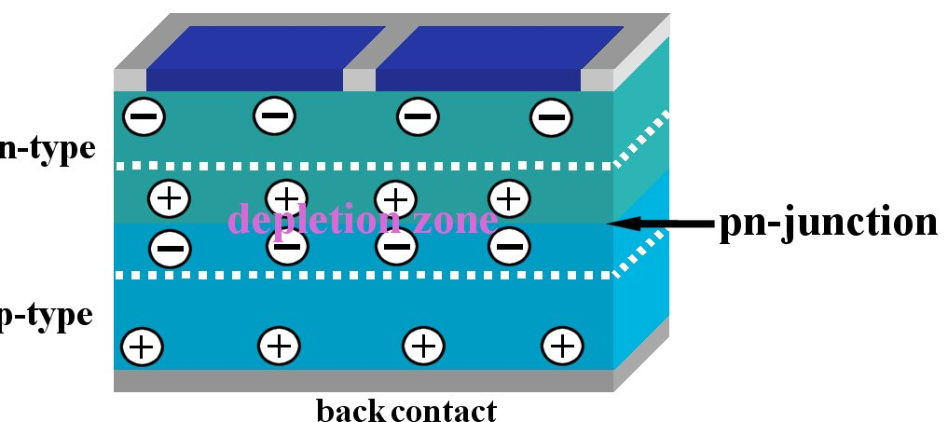
Figure 1: p-n junction

If the cell is shined by light, photons with sufficient energy create hole-electron pairs which are free carriers. The electric field in the depletion region drives these free carriers through the external circuit in the reverse-bias direction. Figure 2 illustrates the basic idea of solar cells.

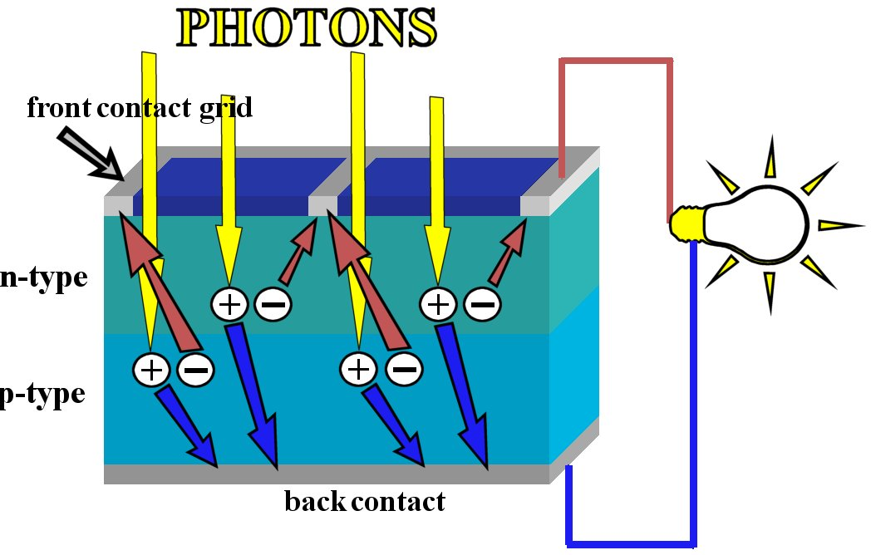
Figure 2: solar cell

Since solar cells are p-n junction the net currant flowing in the cell can be written as [2]:

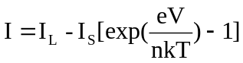 (1.1)

where:
I total current, I_{L} photocurrent, I_{S} saturated current, e electronic charge, V applied voltage, n ideality factor, k Boltzmann’s constant and T is the absolute temperature.

In the case that resistance equals zero, equation 1 becomes:

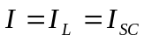 (1.2)

this case is called “short circuit condition“ and the current I_{SC} is called “short circuit current “. On the other hand if the resistance is infinity, equation 1 can be written as:

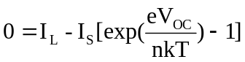 (1.3)
or
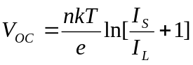 (1.4)

V_{OC} is called “open circuit voltage”.

Considering I_{SC} and V_{OC} there is a parameter called “Fill Factor” or FF equalling the ratio of maximum power P_{max} to I_{SC} multiplied by V_{OC}.

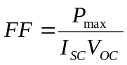 (1.5)

Another quantity of interest is efficiency (η). It is defined as the ratio of output electrical power P_{max} to incident optical power P_{in}. It is given by the equation:

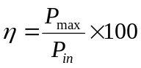 (1.6)

1-2 CdTe/CdS Solar Cells:
There are many materials can be used to fabricate thin films solar cells. Silicon (Si) has been used successfully to make photovoltaic devices. However, it had high cost which forced scientists to find other alternatives. Three materials are the most promising candidates for their relatively low cost and high efficiency. they are CdTe, Cu(In,Ga)Se₂ and amorphous silicon [3].

CdTe/CdS solar cells are among these interesting cells due to the interesting characteristics of both CdTe and CdS. CdTe has a direct band gap varies from 1.45 to 1.5 eV [4-6] which is very close to the optimum value needed for solar cells. Among all six II-VI chalcogenides only CdTe and ZnSe can be either n-type or p-type. ZnSe has not been prepared as polycrystalline material. As a result, the only remaining choice is CdTe [7].

CdS serves as a window layer in CdTe/CdS cells. It has also a direct band gap between 2.4 eV and 2.42 eV [8-11]. Although the mismatch between CdTe and CdS is about 9.7%, the interface does not show high recombination losses [7, 12, 13].

This kind of cells relays on several layers of materials. First of all is the substrate which could be one of different kinds of glass such as soda-lime glass. Second of all is the transparent conducting oxide such as ITO (indium tin oxide). And finally, after making CdS and CdTe layers, is the metal contact which should be ohmic. Figure 3 shows the order of these layers. Some previous studies discussed each layer in details such as the study done by Bonnet [14] and Bosio [12]. In general the active layer in thin film solar cells is in the order of 1 μm [15].

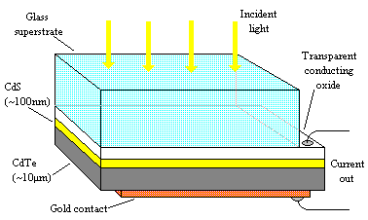
Figure 3: schematic diagram of CdTe/CdS solar cells

CHAPTER 2: LITERATURE REVIEW
2-1 CdS/ITO Interface:
Since solar cells consist of different layers of different materials, performance of solar cells is strongly affected by interface between each two adjacent layers [16]. One of the these interfaces is that of CdS with TCO which still needs more investigation [17, 18].

It has been shown that annealing CdS in air or in oxygen ambient creates a layer of CdO [19]. It some case CdO is not created directly on CdS. It has an intermediate stage such as CdSO₄ [20, 21] and CdO₂ [22]. All these intermediates convert to CdO after annealing. Dimitrov et. al. [20] have shown in their paper many different chemical interactions that can take place to create CdO in different temperatures.

Similarly, different TCO layers as front contacts can affect the performance of the cell[23, 24]. Indium tin oxide (ITO) is commonly used as transparent contact for solar cells. Back contact must be stable during the process of fabrication cells and also must have sheet resistance less than 10 Ω/ and transmission more than 90% [25]. ITO properties depend on the concentration of oxygen. Gullen and Herrero [26] have grown ITO on soda lime glass by sputtering at room temperature. They have found that reducing O₂ concentration caused reduction in optical transmission and sheet resistance. It can be easily understood by knowing that less O₂ leads to more metallic ITO.

Changes in ITO can make significant changes in CdS film too. Both optical and electrical properties of CdS changed due irradiation of ITO surface in the study done by Heo et. al. [27]. In this study, for example, sheet resistance increased with the irradiation doses. In addition, the band gap of CdS was 2.27 eV on as-grown substrate, however, it has been increased to 2.4-2.47 eV on treated ITO. It could be attributed to the improvement in the crystanility. Dramatic variation in the sheet resistance of CdS has happed when it has been deposited on different substrates. The measured value of sheet resistance of as-grown CdS on ITO was 600 Ω/ but it was 10⁸ Ω/ and 10⁶ Ω/ when it was deposited on glass by CBD and vacuum method respectively [28].

2-2 CdTe/CdS Solar Cells:
The interest of this kind of solar cells has been growing since it has been started more than thirty years ago. Bonnet and Rabenhorst [29] started studying CdTe/CdS cells in 1968 and achieved 5-6% efficiency in 1972. CdTe was used as a p-type part of solar cells for the first time in 1970 [29]. In the 1980’s the efficiency of this solar cell was increased to about 10% and then 15.8% reaching 16.5% recently [12]. As all other kinds of solar cells its performance depends on different factors starting from the substrate and ending by making the back contact. Between these two steps there are several kinds of treatments such as CdCl₂ one. As it is mentioned above, the kind of the TCO layer and the treatment that can take place for them change all the properties not only that of CdS but also the properties of CdTe and thereby the performance of the cell [27, 30].

Regardless the technique used in making p-type CdTe based solar cells, these cells face three difficulties [7]:
- Recombination of carriers due to junction interface;
- Doing p-CdTe;
- Forming ohmic contact with p-CdTe.

CdTe and its window layers have been deposited by a lot of techniques such as Chemical Bath Deposition (CBD, for CdS), Closed Space Sublimation (CSS) and Sputtering (ST) [7]. CdS is commonly deposited by CBD [31-33]. However, CSS can be used in order to make CdS film [34, 35]. Some other studies have been done to compare the characteristics of CdS films fabricated by CBD and CSS [36-39].

The properties of films made by CSS technique depend strongly on the deposition conditions such as the temperature of the both the source and the substrate, the separation between them and the gaseous ambient during growth. For example, presence of O₂ during the growth of CdTe and CdS causes to smaller grains leading to less pinholes and more compact films. All these results have been proved by some previous studies [12, 34, 39, 40].

Annealing CdS films in H₂ after growth changes the properties of the film. It has been found that depletion width in the devices made with H₂ annealed CdS was increased from only 1 μm to 3-4 μm [41]. Since O₂ acts as an acceptor in CdS [34], it should be removed from the surface of the film in order to have more n-type films. This can be achieved by annealing CdS in H₂ ambient [42]. Bosio et. al. [12] have found that the amount of O₂ in the surface of CdS (grown in O₂ ambient) has been reduced to only 10% after annealing the sample at 400-420 °C for 30 minuets in 400 mbar of Ar with 20% of H₂. another important effect of H₂ is that it make Cd-rich layer by interacting with S to make H₂S [37]. However, in some cases, H₂ annealing does not make a significant difference [43]. Moreover, H₂ may be destructive since removing S atoms increases re-evaporation of CdS [44].

In order to improve the performance of CdS/CdTe cells, CdCl₂ treatment must take place [43, 45]. This kind of treatment is essential and independent of the used technique [12, 45]. It can applied by several ways such as [46]:
- dipping cells in a solution of CdCl₂ and methanol;
- Evaporating CdCl₂ on cells;
- Backing CdTe in CdCl₂ ambient.
It has been proved that annealing cells after adding CdCl₂ recrystalizes the film and enlarges grain size of CdTe [30, 47]. Dhere et. al. [13] have found that chlorine diffused along grain boundaries and accumulated in the interface of CdS/CdTe. Additionally, chlorine helped S to diffuse in CdTe making CdS more n-type. On the other hand severe treatment of CdCl₂ could kill devices by creating more pinholes and reducing films adhesion [43, 44, 48].

CHAPTER 3: Experimental Procedures

- Cleaning Substrates:
All substrates that have been used in this study were cleaned by the following procedure:
- Each substrate was rubbed with water containing about 3% of DECON-90 soap in order to get rid of grease and fingerprints;
- Rinsed off by DI water;
- 30 minutes in ultrasonic and hot bath of DECON-90 solution. 16 substrates can be held vertically in a custom made holder of PTFE;
- 15 minutes in acetone with ultrasonication;
- 15 minutes in isopropanol with ultrasonication;
- Finally, blown off with dry N₂.

- Annealing Substrates:
Some of the substrates used in the study were annealed, however, some of them were not. For annealed ones used to study ITO/CdS interface, ITO substrates from Visiontek. and Delta Tech. were used. The substrates were pre-treated in A)oxygen and B)nitrogen + hydrogen prior to growth of the CdS layers. Pre-growth annealing was done at 400°C for 10,20,30 and 40 mins in each ambient. A single run was done in oxygen at 550°C for 40 mins. CdS layers were grown on the ITO at about 650°C for the source and about 530 °C for the substrate. Layers were contacted with In dots and their I-V characteristics measured.

The steps of annealing were as following. Substrates were baked in the CdS reactor of the CSS kit. One major difference between samples annealed in O₂ and those annealed in H₂+N₂ is that source material (CdS source) was taken out of the reactor during O₂ annealing. On the other hand, CdS source material was in the reactor during H₂+N₂ annealing. This means that samples annealed in O₂ were taken out after annealing to the atmospheric pressure to put the source back into the reactor. Next, CdS was evaporated on them. However, CdS was deposited on the samples annealed in H₂+N₂ directly after they were cooled down to room temperature. Samples 74 and 75 have been grown on as-grown substrates i.e. the substrates have not been annealed before depositing CdS. However, after finishing CdS growth, the source material was taken out then each sample was annealed in 100 Torr of oxygen for 40 minutes. Similarly, CdS was grown on untreated ITO (Delta) for sample 97 then it was annealed in 15 Torr H₂+60 Torr N₂ directly after growth.
The tables below summarise all samples fabricated for this part of study:

Sample # | Substrate | Ambient | Temp.  (°C) | CdS Thickness (nm) | Time  (min)
49 | VisionTek | 100Torr O₂ | 400 | 370 | 40
50 | VisionTek | 100Torr O₂ | 400 | 290 | 30
51 | VisionTek | 100Torr O₂ | 400 | 280 | 20
52 | VisionTek | 100Torr O₂ | 400 | 430 | 10
53 | VisionTek | --- | ---- | 330 | As grown
54 | VisionTek | 100Torr O₂ | 550 | 120 | 40
55 | VisionTek | 15 Torr H₂+60 Torr N₂ | 400 | 800 | 10
56 | VisionTek | 15 Torr H₂+60 Torr N₂ | 400 | 700 | 20
57 | VisionTek | 15 Torr H₂+60 Torr N₂ | 400 | 430 | 30
58 | VisionTek | 15 Torr H₂+60 Torr N₂ | 400 | 550 | 40
60 | Delta | ------ | ------- | 420 | As grown
61 | Delta | 100Torr O₂ | 400 | 220 | 10
62 | Delta | 100Torr O₂ | 400 | 200 | 20
63 | Delta | 100Torr O₂ | 400 | 290 | 30
64 | Delta | 100Torr O₂ | 400 | 245 | 40
65 | Delta | 15 Torr H₂+60 Torr N₂ | 400 | 600 | 10
66 | Delta | 15 Torr H₂+60 Torr N₂ | 400 | 500 | 20
67 | Delta | 15 Torr H₂+60 Torr N₂ | 400 | 470 | 30
68 | Delta | 15 Torr H₂+60 Torr N₂ | 400 | 450 | 40

Table 1: details of annealing for substrates

Sample # | Substrate | Ambient | Temp.  (°C) | Time  (min)
74 | Visiontek | 100Torr O₂ | 400 | 40
75 | Delta | 100Torr O₂ | 400 | 40
97 | Delta | 15 Torr H₂+60 Torr N₂ | 400 | 40

Table 2: post-growth annealing of CdS/ITO interface.

- CdS Layer (by CSS):
CSS of CdS has been commissioned as a new activity in Durham. The best conditions were identified as: -
CdS layers grown in vacuum with T_{source} = 650 °C and T_{substrate} = 530°C. Source material and source pre-bake: Alfa Aesar CdS powder 99.999%. Pre-baked in vacuum at 400°C for 20 mins and then 650°C for 2 mins before first use. The steps to deposit CdS are summarized as following:
  - After putting the substrate in, the reactor it was pumping out for about 20 min;
- Lower heater was turned on to reach 660°C directly i.e. there was no preheating;
- Shutter was in;
- Shutter was taken out when lower heater reached 660°C;
- Upper heater was not turned on;
- Deposition time was 4 min;
- No ambient gas;
- Termination and cool down: After 4 min. of deposition, the lower heater was turned off and also it was pushed away from the centre of the reactor on its rails. In addition, high flow of N₂ was pumped into the reactor so that it blocks deposition;
- Final cooling: After about 5-10 min, N₂ gas was turned off and the sample was left to cool down.

3-4 Annealing CdS:
CdS films were annealed in CSS kit. Some of them were annealed in the reactor of CdTe and others in the reactor of CdS. However, the procedure of annealing is the same. It started by pumping the reactor out as usual. Then, upper heater was turned on and 60 Torr of N₂ +15 Torr of H₂ were pumped into the reactor. Samples were annealed at 400 °C for 20 minutes. Finally, samples were cooled down by flushing N₂ into the reactor.

- CdTe Layer (by CSS):
CdTe source material was 99.999% pure powder from Alfa Aesar. The source material was pre-bake before first use in two stages, 400°C for 20mins, 610°C for 1min. The same procedure of CdS was used except:
- Deposition temp. was 610°C (600-605°C after taking shutter out);
- Preheating at 400°C for 10 min;
- 2 Torr of N₂ (flow 20.5 mls/m) was pumped at about 500°C to slow growth;
- Deposition time was 1 min;
- No annealing or other in-situ treatment.

- Thickness Measurements:
Alfa Step 200 was used to measure the thickness of CdTe and CdS films. In order to measure thickness with Alfa Step, CdS films were scribed by a tooth-pick dipped in HCl. Next, CdS films were washed with DI water then put in Alfa Step device. For CdTe, on the other hand, films were scratched by a scalpel before measuring thickness.

- CdCl₂ treatment:
CdCl₂ was deposited on CdTe layers by thermal evaporation:
- The pressure of evaporation was about 2-4×10⁻⁴ Torr;
- Shutter was closed until temperature reached ~ 350 °C then it was opened;
- The temperature of deposition was about 450 °C;
- Thickness was monitored by intillemetrics monitor;
- After getting the required thickness, power was turned off and the kit was left to cool down to room temperature;
- Vacuum was broken then all samples were annealed in a tube furnace.

3-8 Etching:
In order to have a clean surface and more p⁺-type CdTe, etching in an acidic solution must take place. It is important since it is the step just before making back contacts. All cells in this study have been etched in NP solution consisted of 70% phosphoric acid (H₃PO₄), 29% water (H₂O) and 1% nitric acid (HNO₃). Cells were dipped in this solution and left there for 10 seconds after seeing bubbles creating on the surface of CdTe. After taking the sample out of the solution, it has been rinsed with DI water and then dried by blowing N₂ gas to it.

- Back Contact:
Two kinds of metals have been used during this study. First was Indium for ITO/CdS interface study. It was done by thermal evaporation at about 10⁻⁶ Torr. 99.999% pure In wire from Alfa Aesar was used to make this kind of contacts. Similarly, gold contacts were done by the same technique but in a different kit. 99.99% pure gold wire from Advent was evaporated in about 10⁻⁵ Torr. A mask with circular holes of 2 mm in diameter was used for In contacts and a similar one was used for Au.

In most cases each sample was broken into four equal parts. Each part was numbered according to its position during growth. Numbering samples helps to compare identical quarters from different samples.

In the next part of this chapter, CSS technique which has been used in this study, will be described briefly followed by a short discussion of J-V characteristics.

A) Close Spaced Sublimation (CSS):
In this technique films are deposited by evaporating the material from a solid source at high temperature. What distinguishes this technique is the short distance between the source and the substrate [49]. High growth rate is a major advantage of CSS [46]. However, the area of the source tray cannot be smaller than that of substrate [46].

At high temperature, source material dissociates and vaporizes then recombines again at the substrate [12]. Both CdS [14, 50] and CdTe can be deposited by CSS [43, 44, 51]. Because the best CdS/CdTe cells had CSS-CdTe, CSS seems to be the best technique for fabricating CdTe [12, 24]. Figure 1 shows a schematic diagram of CSS kit used in Durham University.

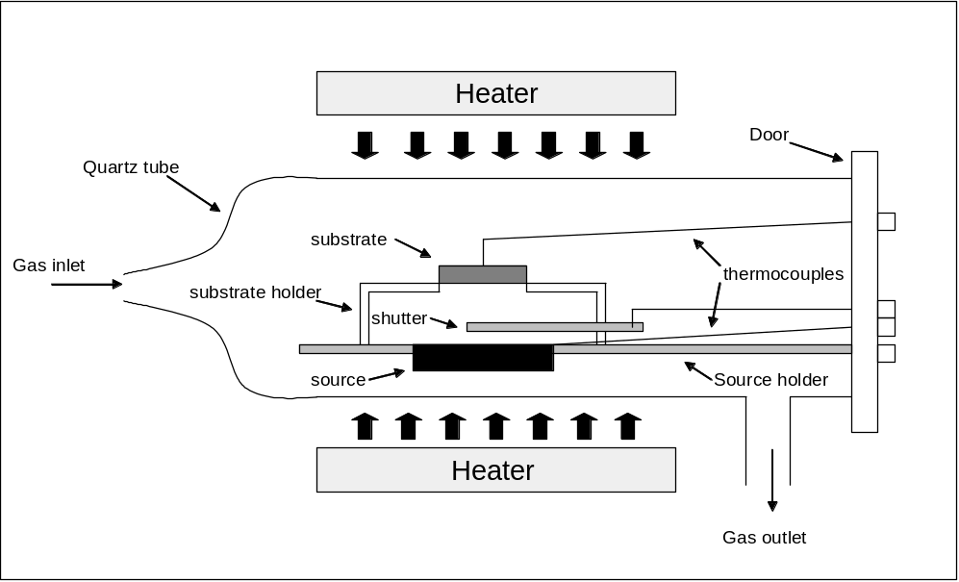

Figure 1: schematic diagram of CSS kit

B) J-V Characteristics:
Since solar cells are p-n junctions, applying DC voltage across them must give J-V curves as shown in figure 2. By looking at equation 1-1:

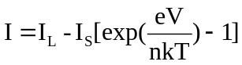

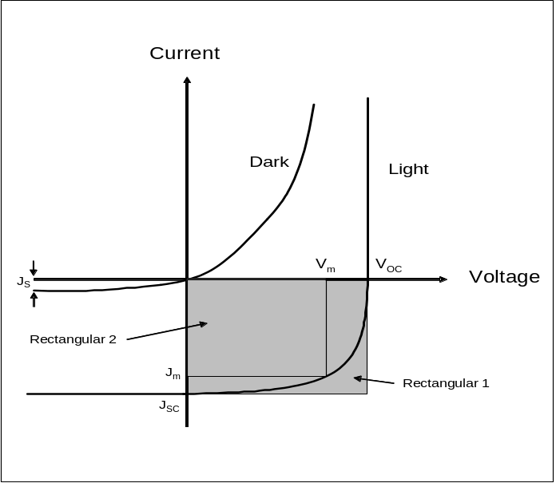
it is obvious that the relationship between J and V are exponential. Additionally, under light, the curve shifts downward due to photocurrent. Important parameters can be extracted from J-V light-curves. From the definition of J_{sc} , which is the current when resistance equals zero, it is equal to the interception of J-V curve with J axes i.e. when V=0. Similarly, interception of the curve with V axis (i.e. J=0) gives V_{OC}. Also Fill Factor,, can be calculated as the ratio of rectangular 2 and rectangular 1.

Figure 2: Dark and light J-V curves for a solar cell.
CHAPTER 4: RESULTS AND DISCUSSION

- CdS/ITO interface:
I-V curves of In/CdS/ITO junctions were measured for all samples listed in tables 1 and 2 in the last chapter. According to Alamri [23], oxidation of ITO increases the work function of it. Consequently, CdS/ITO junction becomes rectifying (figures 1 and 2).
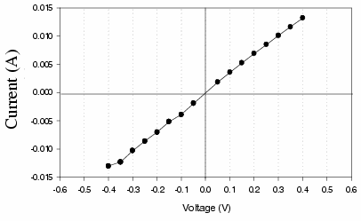

Figure 1: after Alamri 2000 CdS/ITO before annealing

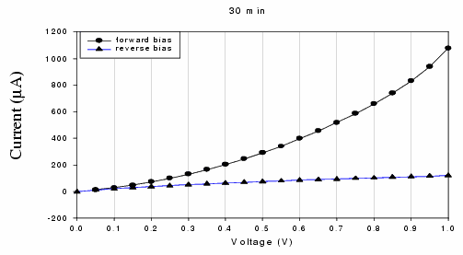

Figure 2: after Alamri 2000 CdS/ITO after annealing
However, in this study, all samples grown on oxidized ITO had ohmic characteristics as shown in figure 3. There were two possible causes for this behaviour. The first one is that CdS films were pinholly that In was contacting ITO directly. Another possibility is that CdS/ITO junction was not changed.

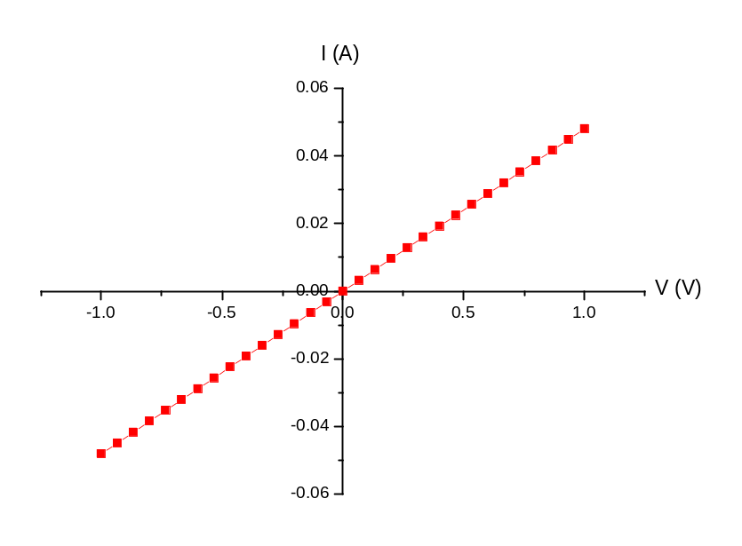
Figure 3:I-V curve for In/CdS/ITO (treated ITO in O₂)

To investigate the presence of pinholes in CdS, Au was evaporated on two of these samples, 49 and 64. It is a fact that Au creates rectifying contacts with CdS [18]. As a result, if the I-V curves of Au/CdS/ITO are rectifying, CdS has no pinholes and hence In/CdS/ITO was always ohmic. Figure 4 shows the I-V characteristics for Au/CdS/ITO junction. The red lines in figures 5 and 6 show the Au dots tested for this aim.

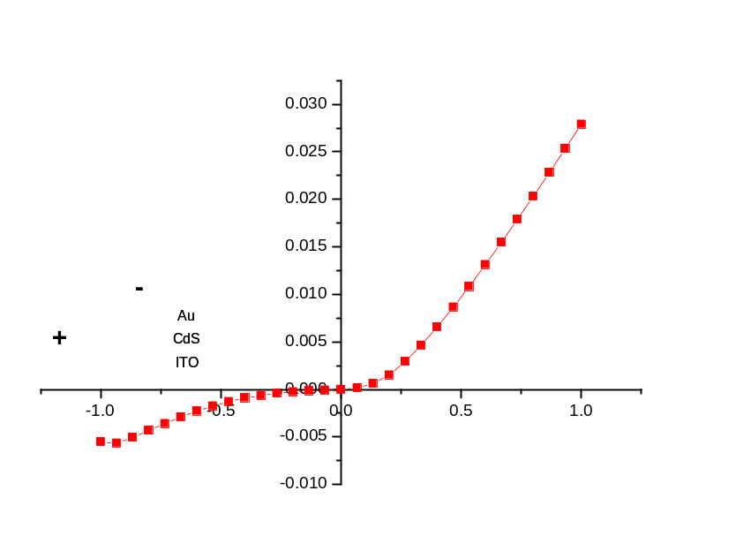
Figure 4: I-V characteristic of Au/CdS/ITO junction

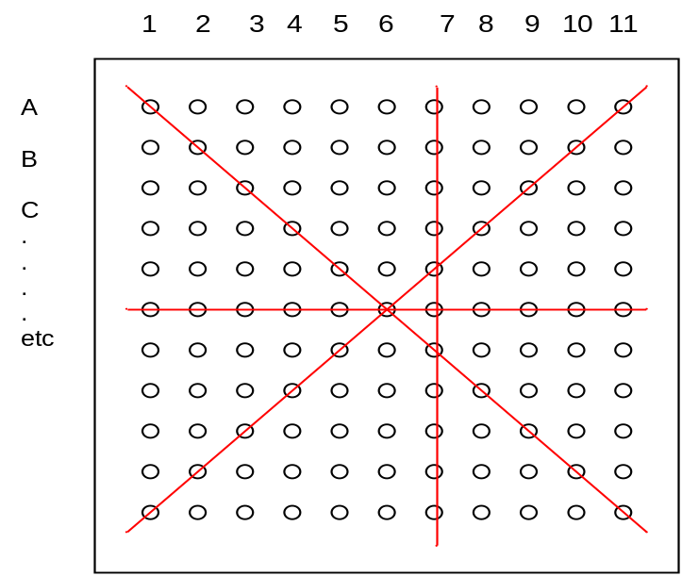

Fig. 5: Au dots deposited on sample 49 (VisionTek.)

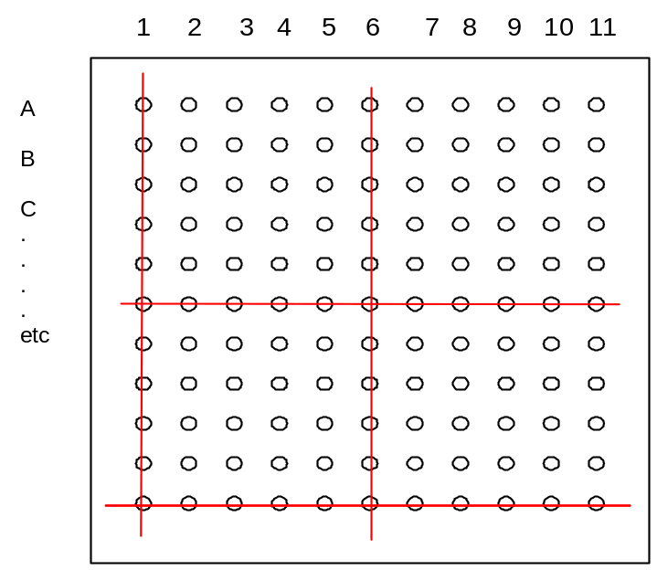

Fig. 6: Au dots deposited on sample 64 (Delta)

For sample 49 (Visiontek substrate) about 1-1.5 cm from edges (almost three dots from each edge) made ohmic contact. In contrast, central dots made rectifying contacts. On other words, CdS films deposited on Visiontek. substrates have a lot of pinholes on edges and good coverage on the centre. However for sample 64 (Delta Tech. substrate) only 3 dots had ohmic behaviour and the rest of dots had rectifying ones including dots near edges. Therefore, only four dots located on the centres of the samples were considered in this study to avoid pinholes.

  - Untreated CdS on Treated ITO:
The thickness of each film was different than others. Therefore, resistivity was considered in this study rather than resistance. Film thicknesses have been measured by Alfa Step 200. By knowing the slope of I-V straight lines and the geometry of the samples, resistivity was calculated for each sample. Figure 7 illustrates the resistivity as a function of annealing time.

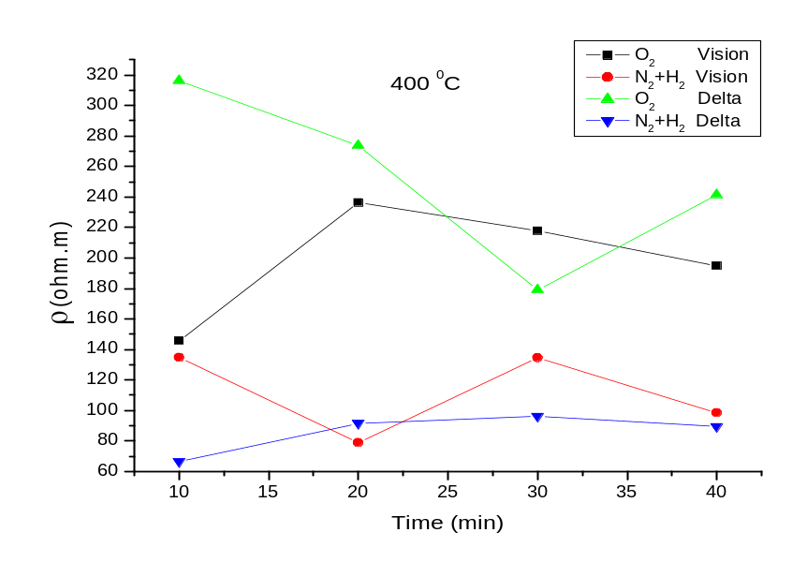

Fig. 7: resistivity ρ of CdS versus annealing time (of substrate)

The resistivity of as-grown substrates was 128.3 Ω.m and 115.7 Ω.m for VisionTek. and Delta Tech. substrates respectively. Generally, it is obvious that annealing substrates in H₂+N₂ reduces the resistivity. On the other hand annealing ITO in O₂ increases it. It can be explained by considering the fact that H₂ reacts with O₂ (reduction). As a result, ITO layer becomes more n-type and hence more conductive[26]. The increase of resistivity for samples annealed in O₂ could be attributed to the same reason.

  - Untreated ITO with Treated CdS:
To investigate this piece of work more, untreated ITO was used to grow CdS on. After growth all samples have been annealed in the same abmients used in the previous part of this study. The annealing temperature was 400 °C and lasted for 40 minuets. The I-V curve of the sample annealed in N₂+H₂ (#97) was a straight line. However, samples annealed in O₂ (# 74-75) had non-linear I-V curves (figure 8).

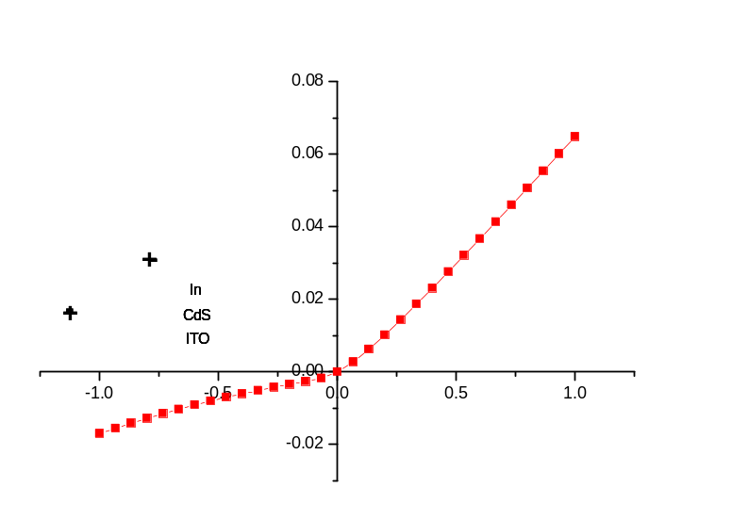

Figure 8: I-V characteristic of Au/CdS/ITO junction

It has been reported in some previous studies that annealing CdS in air creates a layer of CdO on the surface[19-21]. CdO has bang gap energy close to that of CdS (≈ 2.4 eV)[19]. However, the work function of CdO is about 3.44 eV[52] whereas it is about 4.7 eV for CdS[53]. By knowing that In makes an ohmic contact with CdO[54], the rectification behaviour can be tentatively due to the junction between CdS and CdO. Figure 9 illustrates the band diagram of CdO and CdS before and after making the junction.

CdO
CdS
VB
CB
E_{FF}
CB
VB
F
L
VB
E
_{F}
CB
Vacuum
Level
Φ=4.7 eV
CdO
CdS
E
g
=2.4 eV
Eg
=2.4 eV
Φ=3.44

Figure 9: CdO/CdS band diagram before and after making the junction.

Figure 10 shows the polarity of CdTe/CdS solar cells. By comparing figure 8 and figure 10, it is obvious that having CdO layer on the CdS layer could be deleterious to cell performance.
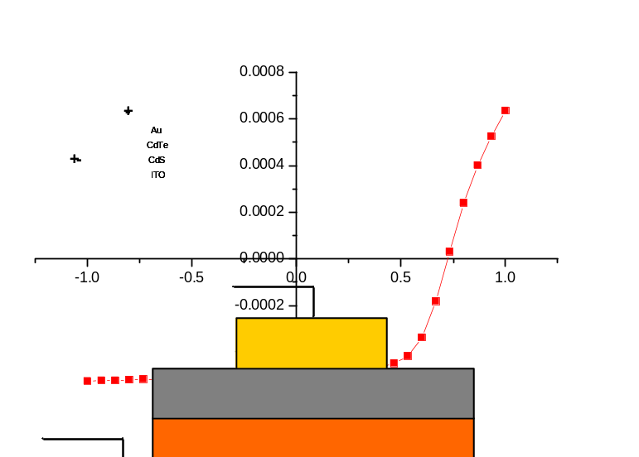
Figure 10: polarity of CdTe/CdS solar cells.
As-grown and annealed CdS/ITO samples were investigated by GIXRD to explore the chemical compounds created on the surface after annealing. As figure 11 shows, the only compound detected on the surface is CdS. In other words, any oxide film that has been created on the surface (if present) is very thin and was not detected by GIXRD.

It seems that GIXRD was not capable for detecting the oxide on the surface of CdS. This means that it is necessary to investigate these samples by other kinds of techniques such as XPS.

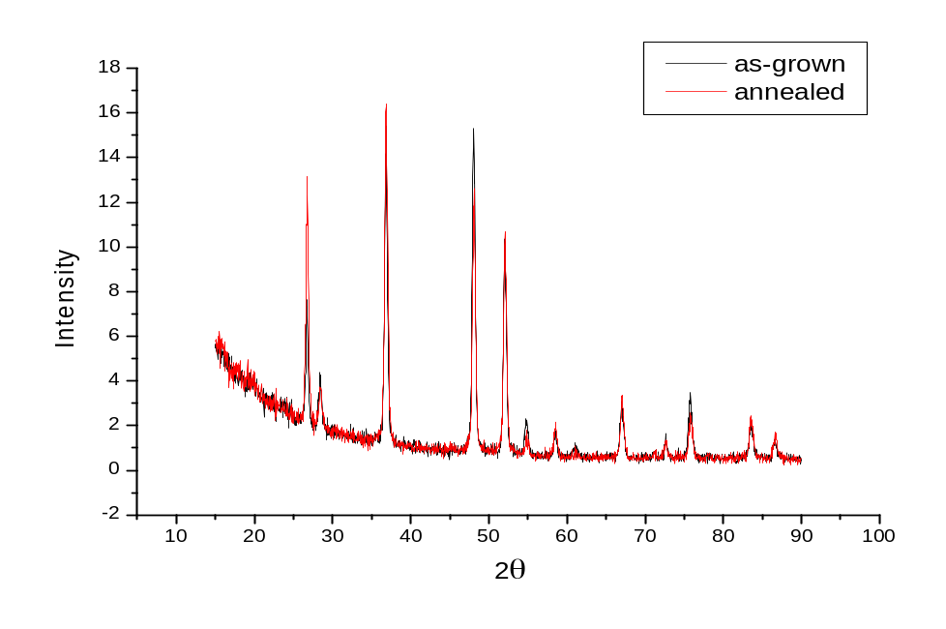

Figure 11: GIXRD of as-grown (black) and annealed (red) CdS/ITO

- Reproducibility of CSS Samples:
In order to test the reproducibility of the samples done by CSS technique, 4 CdS samples and another 4 CdTe samples have been fabricated. Fresh CdS powder (Alfa Aesar 99.999%) has been added to the source before these runs. After putting the fresh material, it was baked at 400C and 650C for 20 and 2 minutes respectively. VisionTeck. substrate were used to grow all samples on. CdS layers grown in vacuum with T_{source} = 650 and T_{substrate} = 530°C and the time of deposition was 4 mins. The thickness was measured by Alfa Step 200.

Similarly, before growing CdTe samples, fresh material was added (99.999% from Alfa Aesar) then baked at 400C and 610C for 20 and 1 minute respectively. CdTe was grown in 2 Torr of N₂ for 1 min. the temperatures of the source and the substrates were 610 °C and 460 °C respectively. Figure 12 shows the positions in which the thickness was measured. Table 1 summarizes the results of CdS samples and table 2 summarizes the CdTe ones.
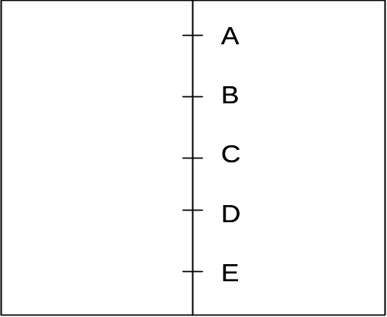

Figure 12: positions of measured thickness

Run 25 | Run 27 |  | Run 28 |  | Run 29 |  | Average |  | SD
Position A (nm) |  | 110 |  | 90 |  | 120 |  | 100 |  |  | 105 | 13
Position B (nm) |  | 120 |  | 160 |  | 120 |  | 100 |  |  | 125 | 25
Position C (nm) |  | 125 |  | 200 |  | 170 |  | 120 |  |  | 154 | 38
Position D (nm) |  | 120 |  | 140 |  | 120 |  | 100 |  |  | 120 | 16
Position E (nm) |  | 120 |  | 120 |  | 100 |  | 95 |  |  | 109 | 13

Table 1: thickness of CdS samples according to the positions shown in figure 12

Run 146 | Run 147 |  | Run 148 |  | Run 149 |  | Average |  | SD
Position A (μm) |  | 8.2 |  | 9 |  | 9.3 |  | 6.1 |  |  | 8.2 | 1.44
Position B (μm) |  | 9.4 |  | 10 |  | 10.5 |  | 7.1 |  |  | 9.3 | 1.5
Position C (μm) |  | 9.3 |  | 9.5 |  | 10.4 |  | 9.8 |  |  | 9.8 | 0.48
Position D (μm) |  | 7 |  | 8 |  | 7.7 |  | 7.4 |  |  | 7.5 | 0.43
Position E (μm) |  | 3.7 |  | 5 |  | 5 |  | 3.4 |  |  | 4.3 | 0.85

Table 2: thickness of CdTe samples according to the positions shown in figure 12

As it is shown above, CSS technique used in this study is capable to reproduce samples. The variation could be due to the change happing to the source after each run. In addition, the temperature of the substrate varied slightly in some cases by the amount not more than ±10 °C. Baking fresh material before making any run is am important step. It helps to get rid of some of the contaminants (if present). Also it helps to solidify the source material so that the heat distribution will be better which results as more uniform films.

- Devices:
During the last year, more than 100 samples have been done. Each sample had about 25 cells.

The first cell was fabricated by using CDB-CdS. The thickness of CdS was 180 nm and the thickness of CdTe was 2-3 μm. This sample was cut into four pieces. Although different thicknesses of CdCl₂ were used in each quarter, the rest of the post-growth treatment was the same i.e. annealing the cell at 380 °C for 20 mins and etching in NP solution for 10 seconds before contacting the cell Au. The results of the best dot of each cell are summarized in the table below. (Only the best dot is considered here since not all of the dots were measured).

The peak of the efficiency was at the quarter treated with 10 nm of CdCl₂. This proves that CdCl₂ treatment is an essential step to improve the performance of solar cells[12, 14, 45, 55]. However, over treating cells with CdCl₂ can be deleterious to the performance[43, 44, 48]. It is clear that the efficiency is not real in these cells. In other words, these values of efficiencies were resulted from the high values of Jsc.
Number of the quarter | CdCl₂ thickness (nm) | η % | FF % | Jsc (mA/cm²) | Voc (V)
125a | 15 | 5.8 | 32.3 | 30.2 | 0.6
125b | 0 | 3.15 | 28.1 | 24 | 0.46
125c | 10 | 7.3 | 40.9 | 33.3 | 0.53
125d | 25 | 5.9 | 42.3 | 24.2 | 0.53

Table 3: cell parameters of run number 125 (CBD-CdS)

After this run, the process has been switched from CBD-CdS to CSS-CdS. The first difference noticed between CSS samples and CBD ones that CSS samples have much fewer short-circuits. This means that the coverage is much better in CSS than in CBD.

Tow runs (138-139) have been done to study the effect of annealing CdS in hydrogen. The thickness of CdS in sample 138 was 200-280 nm and the thickness of CdTe was 1.4-2.5 μm. On the other hand, for sample 139 the thicknesses of CdS and CdTe were 300nm and 1.7-2.5 μm respectively. CdS in sample 139 was annealed in 15 Torr H₂+60 Torr N₂ at 400 °C for 20 mins after growth directly. CdTe for these samples “and all previous samples” was grown in O₂. Oxygen helps to grow more compact CdTe since it effects the nucleation during growth[12, 56]. Standard post growth treatment was done i.e. as the previous runs.

Number of the quarter | CdCl₂ thickness (nm) | η % | FF % | Jsc (mA/cm²) | Voc (V)
138a | 20 | 4.7 | 34 | 25.9 | 0.53
139a | 20 | 5.2 | 38.3 | 29.4 | 0.46
138b | 50 | 4 | 32.5 | 26.3 | 0.46
139b | 50 | 5.1 | 36 | 30.6 | 0.46
138c | 100 | 5.3 | 30.6 | 37 | 0.46
139c | 100 | 5.5 | 37.6 | 31.3 | 0.46
138d | 150 | Delaminated
139d | 150

Table 4: results of runs 138 and 139

Although the Jsc is still high, the cells annealed in H₂ had better efficiency by about 1 %. Improving the performance of cells after annealing CdS has been reported in some other studies [44]. H₂ annealing helps the performance by effecting some properties of CdS such as reducing the number of dangling bonds [37, 44, 57] and also creating more n-type CdS by removing sulphur atoms from the film [37]. Quarters 138d and 139d were over-treated. Therefore, the films of these samples delaminated during NP etch. As it is mentioned above, over treating of CdCl₂ can be harmful to the performance of the cell by creating more pinholes and porous films [43, 44, 48]. Consequently, NP solution might etched CdS film directly.

Since O₂ act as an acceptor also in CdS [35], it was decided to grow CdTe in N₂ instead of O₂. The main goal behind this change is not to compensate sulphur vacancies created during annealing CdS in H₂. However, the efficiencies of all the cells were not promising i.e. less than 2 % in most cases. Table 5 shows an example of these cells. Runs from 151 to 154 have been fabricated in order to check the reproducibility of cells. Standard post-growth treatment with100nm CdCl₂ 20 mins at 380°C in air was done to all these cells.

Run # | Av η% | SD | Best η% | Worst η% | SC ratio
151-2 | 0.87 | 0.46 | 1.93 | 0.3 | 2/25=0.08
152-2 | 1.25 | 0.64 | 1.88 | 0.83 | 3/23=0.13
153-2 | 0.37 | 0.13 | 0.53 | 0.15 | 0/25 = 0.0
154-2 | 0.89 | 0.75 | 3.71 | 0.42 | 7/25=0.28
Average of the 4 runs | 0.85 | 0.49 | 1.9 | 0.43 | 14/98=0.14
Table 5: results of runs from 151 to 154

The performance of solar cells strongly depends on the TCO used as a substrate [23, 25, 27, 28]. Therefore, five different substrates were used to fabricate solar cells. The characteristics and the results of these samples are summarized in tables 6 and 7.

Supplier | TCO | Glass (thickness  type) | Sheet resistance  Ω/
VisonTek | ITO | Soda lime 1.5mm | 15
Merck | ITO | Soda lime 1mm | 22
Hartford Glass | FTO | Soda lime 0.7mm | 18
Pilkington (from  Bath University) | ? | Soda lime 3mm | 18
Delta | ITO | Aluminosilicate  0.7mm | 5-8

Table 6: Description of different TCO’s used to make cells

Run # | Av η % | SD | Best η % | Worst η % | SC ratio
151-154  (VisionTek  ITO) | 0.85 | 0.49 | 1.9 | 0.43 | 14/98=0.14
155-3 (Merck  ITO) | 1.94 | 1.07 | 4.88 | 0.76 | 0/25=0
160-3  (Hartford  Glass FTO) | 1.28 | 0.4 | 2.59 | 0.83 | 1/24=0.04
161-3  (Pilkington) | 0.34 | 0.14 | 0.7 | 0.09 | 0/25 =0
163-3  (Delta ITO) | 2.26 | 3.43 | 10.37 | 0.08 | 0/23=0

Table 7: results of cells done on different kinds of TCO’s

An issue was glass bending at the growth temperature. VisionTek substrate is more likely to bend than the rest of substrates; the aluminosilicate glass from Delta does not bend.

There was only one area (near the edge) in sample 163-3 which had η≈10 %, Jsc= 23.46 mA/cm², Voc=0.73 V, FF=60.2. The light I-V characteristics of this cell are illustrated in figure 13.
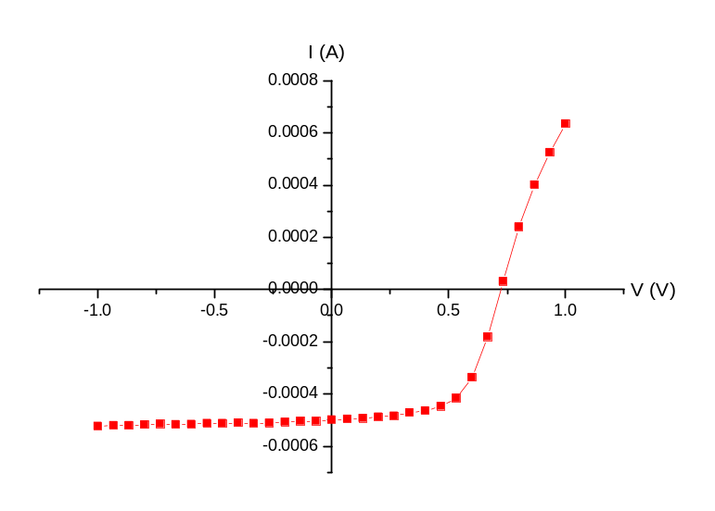
Figure 13: light I-V curve of a cell from sample 136-3

Several runs have been done after 136-3 to reproduce it. Unfortunately, it was impossible to reproduce the “good dot” again. Almost all the dots after sample 136 had buried junctions. Figure 14 shows the quantum efficiency of a buried junction. This means that at sample 136-3, the junction was real by accident.
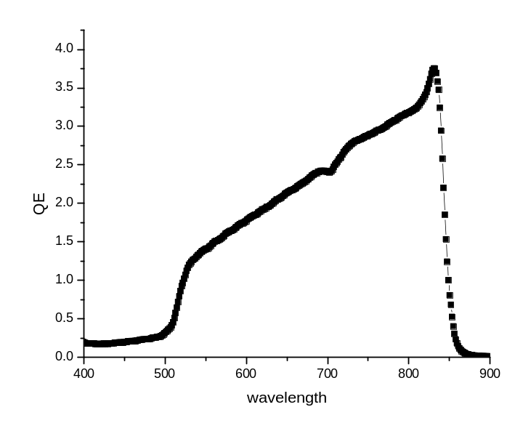
Figure 14: spectral response of a buried junction
Different temperatures of the growth and different thicknesses of films have been tried to improve the performance of the cells. However, none of these cells had worked properly because of the buried junction issue too. The high temperature used in CSS technique could facilitate In diffusion into CdTe layer and, as a result, creates n-CdTe/p-CdTe buried junction [14].

It has been decided by the group that CBD-CdS should be tested again. By using CBD-CdS samples deposited about 6 months ago, some devices have been fabricated. The major difference for this new batch is that CdS was annealed in the CdTe reactor in flowing H₂. Surprisingly, the efficiency jumped to 13.5% (scribed dot). The other parameters of this cell are FF=60 %, Jsc=29.8 mA/cm² and Voc=0.76 V. Figures 15 and 16 show the light I-V curve and the quantum efficiency of this cell, respectively.

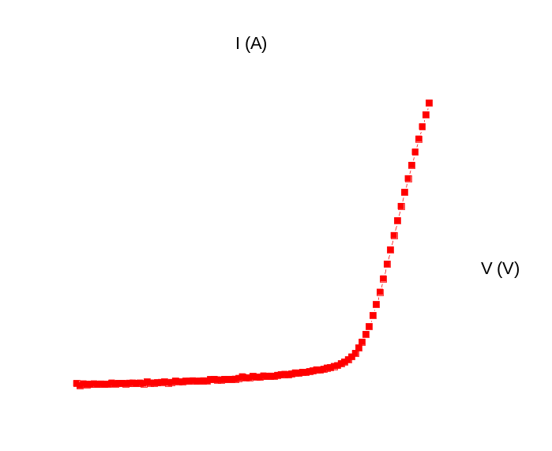
Figure 15: I-V curve in light for a cell with CBD-CdS

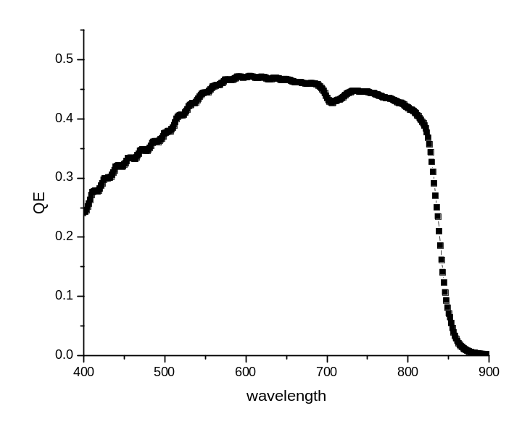
Figure 16: spectral response of a 13.5% cell

This suggests that CSS-CdS should be optimised in order to get at east the same efficiency obtained by CBD-CdS.

CHAPTER 5: FUTURE WORK

- CdS/ITO interface:
- Testing the samples by XPS. Two samples have been sent to Prof. Jaegermann in Germany for this purpose.
- Etching oxidized CdS in diluted HCl solution in order to remove CdO[19] (if it presents) from the surface of CdS. After etching, In contact will be deposited and the I-V curves will be measured again. If the I-V characteristics are ohmic, this proves that the reason of the rectifying behaviour was from the surface. To make sure that etching is not going to create pinholes, Au/CdS junction will be tested again as it was done previously.

- Devices:
CSS-CdS will be grown in highly concentrated ambient of O₂. A 15% efficient CdTe/CSS-CdS cells has been reported [35] in which O₂ was used as a gaseous ambient during CdS growth. O₂ helps to have more compact and dense CdS because it changes the nucleation process. Therefore, thinner CdS film can be used leading to a better performance of the cell. Several pieces of work reported the beneficial roles of O₂ in CdS films [12, 35, 40].

TABLE OF CONTENTS

SUBJECT | PAGE
CHAPTER 1: INTRODUCTION
1-1 General Introduction to Solar Cells | 1
1-2 CdTe/CdS Solar Cells | 4
CHAPTER 2: LITERATURE REVIEW
2-1 CdS/ITO Interface | 6
2-2 CdTe/CdS Solar Cells | 7
CHAPTER 3: EXPERIMENTAL PROCEDURES
3-1 Cleaning Substrates | 10
3-2 Annealing Substrates | 10
3-3 CdS Layer (by CSS) | 13
3-4 Annealing CdS | 14
3-5 CdTe Layer by (CSS) | 14
3-6 Thickness Measurements | 15
3-7 CdCl₂ Treatment | 15
3-8 Etching | 15
3-9 Back Contact | 16
A) Close Spaced Sublimation (CSS) | 17
B) J-V Characteristics | 18
CHAPTER 4: RESULTS AND DISCUSSION
4-1 CdS/ITO Interface | 19
4-1-1 Untreated CdS on Treated ITO | 22
4-1-2 Untreated ITO with Treated CdS | 24
4-2 Reproducibility of CSS samples | 26
4-3 Devices | 29
CHAPTER 5: FUTURE WORK
5-1 CdS/ITO Interface | 37
5-2 Devices | 37

1. G. P. Smestad, Optoelectronics of Solar Cells. (2002) SPIE-The International Society of Optical Engineering
2. D. A. Neamen, Semiconductor Physics and Devices Basic Principles. third (2003) McGRAW-HILL
3. R. H. Mary D. Archer, Clean Electricity From Photovoltaics. (2001) Imperial College Press
4. P. Nollet, M. Burgelman, and S. Degrave, The back contact influence on characteristics of CdTe/CdS solar cells, Thin Solid Films 361-362 (2000) 293-297
5. W. A. Pinheiro, V. D. Falcao, L. R. d. O. Cruz, C. L. Ferreira, Comparative study of CdTe sources used for deposition of CdTe thin films by close spaced sublimation technique, Materials Research vol.9 no.1 (2006) 1516-1439
6. X. Wu, High-efficiency polycrystalline CdTe thin-film solar cells, Solar Energy Thin Film PV 77 (2004) 803-814
7. R. H. Bube, Photovoltaic Materials. 2 (2006) Imperial College Press
8. X. D. Wu, R.G. Yan, Y. Romero, I.J. Zhang, Y. Zhou, J. DeHart, C. Duda, A. Perkins, C. To, B., High-efficiency polycrystalline CdTe thin-film solar cells with an oxygenated amorphous cds (a-CdS:O) window layer, Photovoltaic Specialists Conference, (2002) 531- 534
9. D. Shvydka, J. Drayton, A. D. Compaan, and V. G. Karpov, Piezo-effect and physics of CdS-based thin-film photovoltaics, Applied Physics Letters 87 (2005) 123505
10. W. G. F. Cardon, W. Dekeyser, Photovoltaic and Photoelectrochemical Solar Energy Conversion. 1 (1981) Plenum Press with NATO Scientific Affairs Division
11. S. Larach, Photoelectronic Material and Devices. (1965) D. Van Nostrand Company, Inc.
12. A. Bosio, N. Romeo, S. Mazzamuto, and V. Canevari, Polycrystalline CdTe thin films for photovoltaic applications, Progress in Crystal Growth and Characterization of Materials 52 (2006) 247-279
13. R. R. Dhere, D. Albin, D. Asher, S. Al-Jassim, M. Cheong, H. Swartzlander, A. Moutinho, H. Coutts, T. Ribelin, R. Sheldon, P., Influence of CdS/CdTe interface properties on the device properties, Photovoltaic Specialists Conference, 1997., Conference Record of the Twenty-Sixth IEEE, CA, USA (1997) 435-438
14. D. Bonnet, Manufacturing of CSS CdTe solar cells, Thin Solid Films 361-362 (2000) 547-552
15. R. M. R. Overstraeten, Physics, Technology and Use of Photovoltaics. (1986) Adam Hilger
16. Z. C. Feng, H. C. Chou, A. Rohatgi, G. K. Lim, A. T. S. Wee, and K. L. Tan, Correlations between CdTe/CdS/SnO[sub 2]/glass solar cell performance and the interface/surface properties, Journal of Applied Physics 79 (1996) 2151-2153
17. T. S. J. Fritsche, A. Thißen, A. Klein, W. Jaegermann, Interface modification of CdTe thin film solar cells by CdCl -activation 2, Thin Solid Films 431 –432 (2003) 267–271
18. B. K. Patel, K. K. Nanda, and S. N. Sahu, Interface characterization of nanocrystalline CdS/Au junction by current--voltage and capacitance--voltage studies, Journal of Applied Physics 85 (1999) 3666-3670
19. O. G. Daza, P K Nair, A Arias-Carbajal Re´adigos, J Campos and M. T. S. Nair, Formation of conductive CdO layer on CdS thin films during air heating, Semicond. Sci. Technol. 16 (2001) 651–656
20. R. I. Dimitrov, N. Moldovanska, and I. K. Bonev, Cadmium sulphide oxidation, Thermochimica Acta 385 (2002) 41-49
21. P. J. Sebastian and M. E. Calixto, Porous CdS:CdO composite structure formed by screen printing and sintering of CdS in air, Thin Solid Films 360 (2000) 128-132
22. L. R. de Leon-Gutierrez, J. J. Cayente-Romero, J. M. Peza-Tapia, E. Barrera-Calva, J. C. Martinez-Flores, and M. Ortega-Lopez, Some physical properties of Sn-doped CdO thin films prepared by chemical bath deposition, Materials Letters 60 (2006) 3866-3870
23. S. N. Alamri and A. W. Brinkman, The effect of the transparent conductive oxide on the performance of thin film CdS/CdTe solar cells, Journal of Physics D: Applied Physics 33 (2000) L1-L4
24. N. Romeo, A. Bosio, V. Canevari, M. Terheggen, and L. Vaillant Roca, Comparison of different conducting oxides as substrates for CdS/CdTe thin film solar cells, Thin Solid Films Proceedings of Symposium B, Thin Film Chalcogenide Photovoltaic Materials, E-MRS Spring Meeting 431-432 (2003) 364-368
25. S. N. ALAMRI., Effect of Transparent Conductive Oxide Stability on CdS/CdTe Solar Cell Performance, Jpn. J. Appl. Phys. 41 Part 2, No. 10A (2002) L 1052–L 1054
26. C. Guillen and J. Herrero, Stability of sputtered ITO thin films to the damp-heat test, Surface and Coatings Technology 201 (2006) 309-312
27. J. Heo, H. Ahn, R. Lee, Y. Han, and D. Kim, Influence of ITO surface modification on the growth of CdS and on the performance of CdS/CdTe solar cells, Solar Energy Materials and Solar Cells 75 (2003) 193-201
28. S.Q. Xi, Hai-Ning Cui, The fabrication of dipped CdS and sputtered ITO thin films for photovoltaic solar cells, Thin Solid Films 288 (1996) 325-329
29. D. Bonnet, H. Rabenhorst, NEW RESULTS ON THE DEVELOPMENT OF A THIN-FILM p-CdTe-n-CdS HETEROJUNCTION SOLAR CELL, Proceeding of the Ninth Photovoltaic Specialist Coference, (1972) 129-131
30. A. Romeo, D. L. Batzner, H. Zogg, and A. N. Tiwari, Recrystallization in CdTe/CdS, Thin Solid Films 361-362 (2000) 420-425
31. E. V. Grushko, L. A. Kosyachenko, V. V. Motushchuk, Recombination losses in thin-film CdS/CdTe photovoltaic devices, Solar Energy Material & Solar Cells 90 (2006) 2201-2212
32. J. Herrero, M. T. Gutierrez, C. Guillen, J. M. Dona, M. A. Martinez, A. M. Chaparro, and R. Bayon, Photovoltaic windows by chemical bath deposition, Thin Solid Films 361-362 (2000) 28-33
33. M. Alturkestani, Electrical and Optical Properties of Chemically Deposited Semiconducting Films, MSc, (2005), King Abdul Aziz
34. D. Marinskaya. C. S. FEREKIDES, B. TETALI, D. OMAN, AND D. L. MOREL, CDS FILMS PREPARED MY THE CLOSE-SPACED SUBLIMATION AND THEIR INFLUENCE ON CDTE/CDS SOLAR CELL PERFORMANCE, 25th PVSC, Wshington (1996) 751-756
35. C. S. Ferekides, D. Marinskiy, V. Viswanathan, B. Tetali, V. Palekis, P. Selvaraj, and D. L. Morel, High efficiency CSS CdTe solar cells, Thin Solid Films 361-362 (2000) 520-526
36. A. I. Oliva, O. Solis-Canto, R. Castro-Rodriguez, and P. Quintana, Formation of the band gap energy on CdS thin films growth by two different techniques, Thin Solid Films 391 (2001) 28-35
37. Y. H. Lee, W. J. Lee, Y. S. Kwon, G. Y. Yeom, and J. K. Yoon, Effects of CdS substrates on the physical properties of polycrystalline CdTe Films, Thin Solid Films 341 (1999) 172-175
38. D. R. Albin, D. Dhere, R. Levi, D. Woods, L. Swartzlander, A. Sheldon, P., Comparison of Close-Spaced Sublimated and Chemical Bath Deposited CdS Films: Effects on CdTe Solar Cells., 26th IEEE Photovoltaic Specialists Conference, Anaheim, California (1997)
39. A. I. Oliva, R. Castro-Rodriguez, O. Solis-Canto, V. Sosa, P. Quintana, and J. L. Pena, Comparison of properties of CdS thin films grown by two techniques, Applied Surface Science 205 (2003) 56-64
40. D. Levi, D. ROSE, R. MASTON, D. ALBINR. DHERE, AND P. SHELDON, THE ROLE OF OXYGEN IN CdS/CdTe SOLAR CELLS DEPOSITED BY CLOSE-SPACED SUBLIMATION, 5th PVSC, Washington, D.C. (1996) 777-780
41. J. Britt, C. Ferekides, Y. Ma, and L. Killian, HIGH EFFICIENCY CdTe SOLAR CELLS BY CLOSE SPACED SUBLIMATION., IEEE (1993) 389-393
42. K. M. Jaan Hiie, Vello Valdna, Structural and Electrical Properties of Chemical Bath Deposited CdS Films: Annealing Effect, E-MRS IUMRS ICEM 2006 Spring Meeting, Nice, France (2006)
43. F. S. Hasson, Doug H. Rose, Ramesh G. Dhere, Dave S. Albin, Rosine M. Ribelin, Xiaonan S. Li, Yoxa Mahathongdy, Tim A. Gessert, Pete Sheldon, Fabrication procedures and process sensitivities for CdS/CdTe solar cells, Progress in Photovoltaics: Research and Applications 7 (1999) 331-340
44. H. Kim and D. Kim, Influence of CdS heat treatment on the microstructure of CdS and the performance of CdS/CdTe solar cells, Solar Energy Materials and Solar Cells 67 (2001) 297-304
45. A. Morales-Acevedo, Can we improve the record efficiency of CdS/CdTe solar cells?, Solar Energy Materials and Solar Cells Selected Papers from the Solar Cells and Solar Energy Materials Symposium -IMRC 2005 90 (2006) 2213-2220
46. P. Capper, Narrow-gap II-VI Compounds for Optoelectrocin and electromagnetic Applications. 1, ed. R.H. A. Willoughby (1997) Chpman & Hall
47. H.Y. Lee, Jae-Hyung Lee, Yong-Kwan Park, Sung-Ho Shin and Kwang-Ja Park, Effects of the Annealing Temperature and CdCl2 Treatment on the Photovoltaic Properties of the CdS/CdTe Solar Cell, Japanese Journal of Applied Physics 37 (1998) 3357-3362
48. A. Romeo, D. L. Batzner, H. Zogg, C. Vignali, and A. N. Tiwari, Influence of CdS growth process on structural and photovoltaic properties of CdTe/CdS solar cells, Solar Energy Materials and Solar Cells 67 (2001) 311-321
49. C. Cohen-Solal, M. Barbe, H. Afifi, and G. Neu, Thin film CdTe solar cells, Journal of Crystal Growth 72 (1985) 512-524
50. D. L. Batzner, R. Wendt, A. Romeo, H. Zogg, and A. N. Tiwari, A study of the back contacts on CdTe/CdS solar cells, Thin Solid Films 361-362 (2000) 463-467
51. S. K. Tetsuya Aramoto, Hiroshi Higuchi, Takashi Arita, Satoshi Shibutani, Tuyoshi Nishio, Junji Nakajima, Miwa Tsuji, Akira Hanafusa, Takeshi Hibino, Kuniyoshi Omura, Hideaki Ohyama and Mikio Murozono, 16.0% Efficient Thin-Film CdS/CdTe Solar Cells, Jpn. J. Appl. Phys. 36 (1997) 6304-6305
52. R. Ferro and J. A. Rodriguez, Influence of F-doping on the transmittance and electron affinity of CdO thin films suitable for solar cells technology, Solar Energy Materials and Solar Cells 64 (2000) 363-370
53. G. Liu, T. Schulmeyer, J. Brotz, A. Klein, and W. Jaegermann, Interface properties and band alignment of Cu2S/CdS thin film solar cells, Thin Solid Films Proceedings of Symposium B, Thin Film Chalcogenide Photovoltaic Materials, E-MRS Spring Meeting 431-432 (2003) 477-482
54. G. I. Russ. R. S. Rusu, ON THE ELECTRICAL AND OPTICAL CHARACTERISTICS OF CdO THIN FILMS, Journal of Optoelectronics and Advanced Materials 7 (2005) 823 - 828
55. H.-Y. t. Jae-Hyung Lee, Yong-Kwan Park, Sung-Ho Shin and Kwang-Ja Park2, Effects of the Annealing Temperature and CdCl2 Treatment on the Photovoltaic Properties of the CdS/CdTe Solar Cell, Jpn. J. Appl. Phys. 37 (1998) 3357-3362
56. Y. Yan, D.S. Albin, M.M. Al-Jassim,, The effect of oxygen on interface microstructure evolution in CdS/CdTe solar cells, Progress in Photovoltaics: Research and Applications 10 (2002) 309-322
57. A. Morales-Acevedo, Physical basis for the design of CdS/CdTe thin film solar cells, Solar Energy Materials and Solar Cells Selected Papers from the International Symposium on Solar Cells & Solar Energy Materials 90 (2006) 678-685

